{
"content": [
{
"id": "d43c43ed-6475-4343-b294-db2c1385a447",
"humanReadableId": "TF-0013-00000002",
"region": "Москва и Московская область",
"regionId": "da9682d8-d80e-4231-a913-612a84ba7d36",
"transportType": "PERSONAL",
"serviceType": "EMPLOYEE_TRANSPORTATION",
"active": true,
"organizationId": "f82c7d1d-bc8e-4bfd-ae27-f3fc22941663",
"isNightTariff": false
},
{
"id": "58288f8e-e5d2-4a45-a01f-fa6d3181b3df",
"humanReadableId": "TF-0013-00000003",
"regionId": "da9682d8-d80e-4231-a913-612a84ba7d36",
"transportType": "PUBLIC",
"serviceType": "EMPLOYEE_TRANSPORTATION",
"active": true,
"organizationId": "f82c7d1d-bc8e-4bfd-ae27-f3fc22941663",
"isNightTariff": false
},
{
"id": "7c1d49c3-b7ab-41d0-b7cb-bf8dea800295",
"humanReadableId": "TF-0013-00000024",
"regionId": "c526065a-9d20-4889-9921-83adcb217b61",
"transportType": "PUBLIC",
"serviceType": "EMPLOYEE_TRANSPORTATION",
"active": true,
"organizationId": "f82c7d1d-bc8e-4bfd-ae27-f3fc22941663",
"isNightTariff": false
},
{
"id": "b840cb43-aa5f-4fe5-bc13-cd286478ce77",
"humanReadableId": "TF-0013-00000037",
"region": "Москва и Московская область",
"regionId": "c526065a-9d20-4889-9921-83adcb217b61",
"transportType": "TAXI",
"serviceType": "EMPLOYEE_TRANSPORTATION",
"active": true,
"organizationId": "f82c7d1d-bc8e-4bfd-ae27-f3fc22941663",
"contractId": "b19b61f0-cbbb-49d8-bea8-4514e063b68c",
"contractNumber": "10-9900-0054",
"contractorId": "de8b3919-50f1-40fd-905e-2c9ce51499c4",
"contractorName": "БИБИ-КАР",
"isNightTariff": false
},
{
"id": "d3ac2483-3382-47ed-956c-e57df352f1ce",
"humanReadableId": "TF-0013-00000038",
"region": "Приморский край",
"regionId": "0f9eac43-d3ce-4fdd-b05a-096b972e82a7",
"transportType": "TAXI",
"serviceType": "EMPLOYEE_TRANSPORTATION",
"active": true,
"organizationId": "f82c7d1d-bc8e-4bfd-ae27-f3fc22941663",
"contractId": "8c638395-1c04-4dee-9519-08b431afe0dc",
"contractNumber": "112",
"contractorId": "db501ee2-2967-4c82-93b6-b366fe7bc011",
"contractorName": "ИП Широков В.А.",
"isNightTariff": false
},
{
"id": "2462cca7-7efe-4595-97bc-6657502109c3",
"humanReadableId": "TF-0013-00000040",
"region": "Москва и Московская область",
"regionId": "c526065a-9d20-4889-9921-83adcb217b61",
"transportType": "TAXI",
"serviceType": "EMPLOYEE_TRANSPORTATION",
"active": true,
"organizationId": "f82c7d1d-bc8e-4bfd-ae27-f3fc22941663",
"contractId": "b19b61f0-cbbb-49d8-bea8-4514e063b68c",
"contractNumber": "10-9900-0054",
"contractorId": "de8b3919-50f1-40fd-905e-2c9ce51499c4",
"contractorName": "БИБИ-КАР",
"isNightTariff": false
},
{
"id": "85ead012-3f06-4c02-bddd-2e2ef8809a85",
"humanReadableId": "TF-0013-00000042",
"region": "Москва и Московская область",
"regionId": "c526065a-9d20-4889-9921-83adcb217b61",
"transportType": "TAXI",
"serviceType": "EMPLOYEE_TRANSPORTATION",
"active": true,
"organizationId": "f82c7d1d-bc8e-4bfd-ae27-f3fc22941663",
"contractId": "b19b61f0-cbbb-49d8-bea8-4514e063b68c",
"contractNumber": "10-9900-0054",
"contractorId": "de8b3919-50f1-40fd-905e-2c9ce51499c4",
"contractorName": "БИБИ-КАР",
"isNightTariff": false
},
{
"id": "05d5806c-5d3f-4648-b00a-bc4d1a901acf",
"humanReadableId": "TF-0013-00000044",
"region": "Ростовская область",
"regionId": "98f16368-baac-4876-a4ae-2f5608e12e2d",
"transportType": "TAXI",
"serviceType": "EMPLOYEE_TRANSPORTATION",
"active": true,
"organizationId": "f82c7d1d-bc8e-4bfd-ae27-f3fc22941663",
"contractId": "2b8ba0ad-f10c-4a6b-b465-254bcbbd6e86",
"contractNumber": "5000000000",
"contractorId": "8b9cd8bb-643e-46d9-b558-7b5f395d673c",
"contractorName": "Служебный Ростов",
"isNightTariff": false
},
{
"id": "84b21e16-93c3-4a38-a0dd-158651b72bdb",
"humanReadableId": "TF-0013-00000045",
"region": "Оренбургская область",
"regionId": "841c96a9-c690-4248-b121-5774e5a84ebb",
"transportType": "TAXI",
"serviceType": "EMPLOYEE_TRANSPORTATION",
"active": true,
"organizationId": "f82c7d1d-bc8e-4bfd-ae27-f3fc22941663",
"contractId": "08d1fb90-bff2-44d7-9769-a898e2f063fb",
"contractNumber": "22-01-862300130",
"contractorId": "b69d99de-addb-48a8-9072-92316c095173",
"contractorName": "ООО Бен-Газ-Сакмара",
"isNightTariff": false
},
{
"id": "c82a5af0-f743-4dbb-b946-eb62ba538311",
"humanReadableId": "TF-0013-00000046",
"regionId": "c526065a-9d20-4889-9921-83adcb217b61",
"transportType": "PERSONAL",
"serviceType": "EMPLOYEE_TRANSPORTATION",
"active": true,
"organizationId": "f82c7d1d-bc8e-4bfd-ae27-f3fc22941663",
"isNightTariff": false
},
{
"id": "3c265ed2-dd90-4516-9734-6acf87c99166",
"humanReadableId": "TF-0013-00000048",
"region": "Москва и Московская область",
"regionId": "c526065a-9d20-4889-9921-83adcb217b61",
"transportType": "GROUP_TRANSFER",
"serviceType": "EMPLOYEE_TRANSPORTATION",
"active": true,
"organizationId": "f82c7d1d-bc8e-4bfd-ae27-f3fc22941663",
"contractId": "b928de84-e698-4f95-88d9-c1607fb182a3",
"contractNumber": "301",
"contractorId": "62661628-7868-4428-b009-b0d06ed7d29c",
"contractorName": "Автопарк Транспортные решения АПИ",
"isNightTariff": false
},
{
"id": "73b4afcf-f35c-4e12-abe8-31249ab33991",
"humanReadableId": "TF-0013-00000049",
"region": "Алтайский край",
"regionId": "35b299c1-3b81-44da-bfdc-0c474bcdefc9",
"transportType": "GROUP_TRANSFER",
"serviceType": "EMPLOYEE_TRANSPORTATION",
"active": true,
"organizationId": "f82c7d1d-bc8e-4bfd-ae27-f3fc22941663",
"contractId": "b928de84-e698-4f95-88d9-c1607fb182a3",
"contractNumber": "301",
"contractorId": "62661628-7868-4428-b009-b0d06ed7d29c",
"contractorName": "Автопарк Транспортные решения АПИ",
"isNightTariff": false
},
{
"id": "509ecaa9-4f7d-48a0-a276-44e896dc5e92",
"humanReadableId": "TF-0013-00000050",
"region": "Республика Алтай",
"regionId": "83227575-7b0d-4be8-9043-4c257ba2de30",
"transportType": "GROUP_TRANSFER",
"serviceType": "EMPLOYEE_TRANSPORTATION",
"active": true,
"organizationId": "f82c7d1d-bc8e-4bfd-ae27-f3fc22941663",
"contractId": "b928de84-e698-4f95-88d9-c1607fb182a3",
"contractNumber": "301",
"contractorId": "62661628-7868-4428-b009-b0d06ed7d29c",
"contractorName": "Автопарк Транспортные решения АПИ",
"isNightTariff": false
},
{
"id": "a4b6e7ff-4f3b-4485-af4b-43b2f5eeb62e",
"humanReadableId": "TF-0013-00000051",
"region": "Москва и Московская область",
"regionId": "c526065a-9d20-4889-9921-83adcb217b61",
"transportType": "TAXI",
"serviceType": "EMPLOYEE_TRANSPORTATION",
"active": true,
"organizationId": "f82c7d1d-bc8e-4bfd-ae27-f3fc22941663",
"contractId": "dc1af64d-e45b-4f1e-b5a2-d81ade29be32",
"contractNumber": "101",
"contractorId": "62661628-7868-4428-b009-b0d06ed7d29c",
"contractorName": "Автопарк Транспортные решения АПИ",
"isNightTariff": false
},
{
"id": "14c907ef-8dcf-4ef6-9d49-68f0abab7597",
"humanReadableId": "TF-0013-00000052",
"region": "Москва и Московская область",
"regionId": "c526065a-9d20-4889-9921-83adcb217b61",
"transportType": "TAXI",
"serviceType": "EMPLOYEE_TRANSPORTATION",
"active": true,
"organizationId": "f82c7d1d-bc8e-4bfd-ae27-f3fc22941663",
"contractId": "dc1af64d-e45b-4f1e-b5a2-d81ade29be32",
"contractNumber": "101",
"contractorId": "62661628-7868-4428-b009-b0d06ed7d29c",
"contractorName": "Автопарк Транспортные решения АПИ",
"isNightTariff": false
},
{
"id": "86e1a7ac-0867-4f6b-8320-208ddb704364",
"humanReadableId": "TF-0013-00000053",
"region": "Республика Алтай",
"regionId": "83227575-7b0d-4be8-9043-4c257ba2de30",
"transportType": "TAXI",
"serviceType": "EMPLOYEE_TRANSPORTATION",
"active": true,
"organizationId": "f82c7d1d-bc8e-4bfd-ae27-f3fc22941663",
"contractId": "dc1af64d-e45b-4f1e-b5a2-d81ade29be32",
"contractNumber": "101",
"contractorId": "62661628-7868-4428-b009-b0d06ed7d29c",
"contractorName": "Автопарк Транспортные решения АПИ",
"isNightTariff": false
},
{
"id": "e145c612-b867-4ddf-be26-26417644e3d1",
"humanReadableId": "TF-0013-00000055",
"region": "Москва и Московская область",
"regionId": "c526065a-9d20-4889-9921-83adcb217b61",
"transportType": "TAXI",
"serviceType": "EMPLOYEE_TRANSPORTATION",
"active": true,
"organizationId": "f82c7d1d-bc8e-4bfd-ae27-f3fc22941663",
"contractId": "dc1af64d-e45b-4f1e-b5a2-d81ade29be32",
"contractNumber": "101",
"contractorId": "62661628-7868-4428-b009-b0d06ed7d29c",
"contractorName": "Автопарк Транспортные решения АПИ",
"isNightTariff": false
}
],
"pageable": {
"pageNumber": 0,
"pageSize": 50,
"sort": [
{
"direction": "ASC",
"property": "humanReadableId",
"ignoreCase": false,
"nullHandling": "NATIVE",
"descending": false,
"ascending": true
}
],
"offset": 0,
"unpaged": false,
"paged": true
},
"totalPages": 1,
"totalElements": 17,
"last": true,
"numberOfElements": 17,
"size": 50,
"number": 0,
"sort": [
{
"direction": "ASC",
"property": "humanReadableId",
"ignoreCase": false,
"nullHandling": "NATIVE",
"descending": false,
"ascending": true
}
],
"first": true,
"empty": false
}

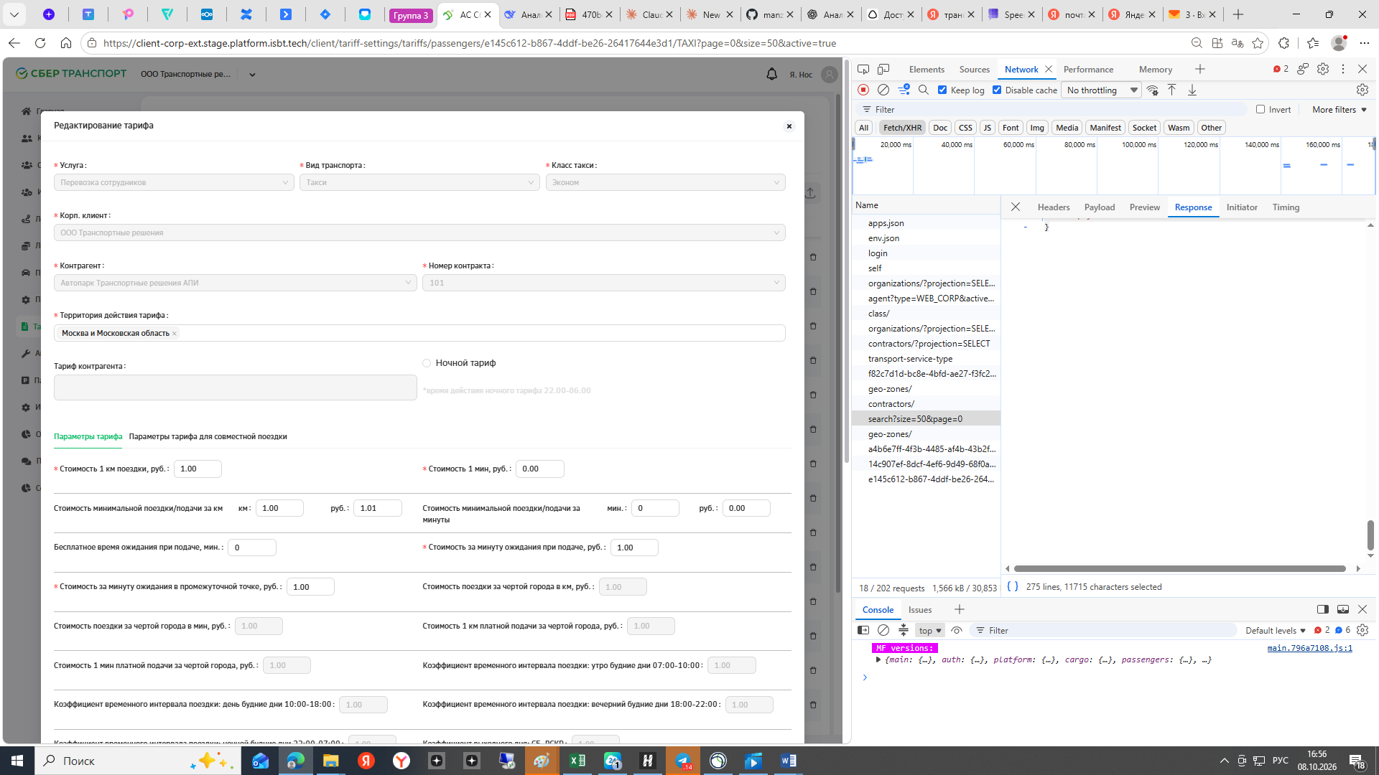

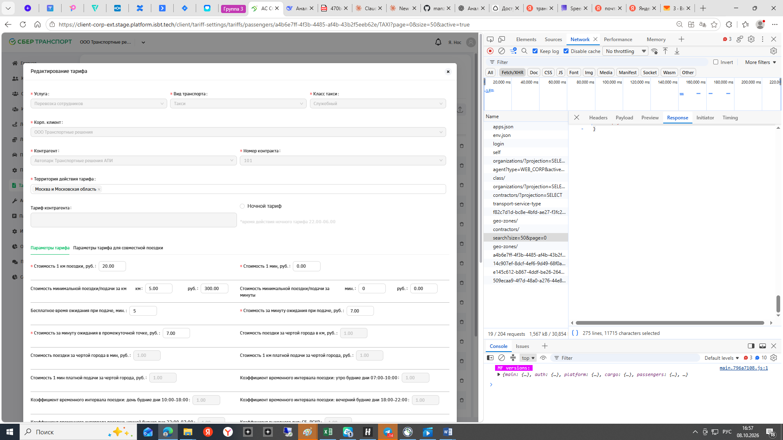

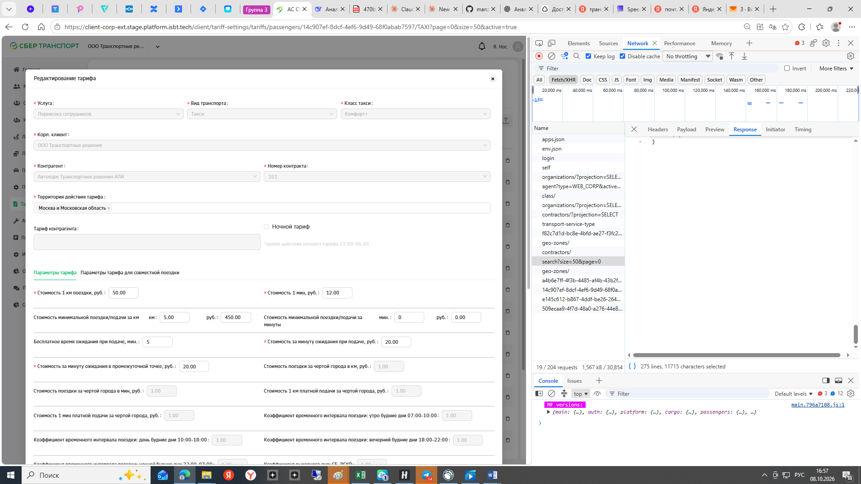
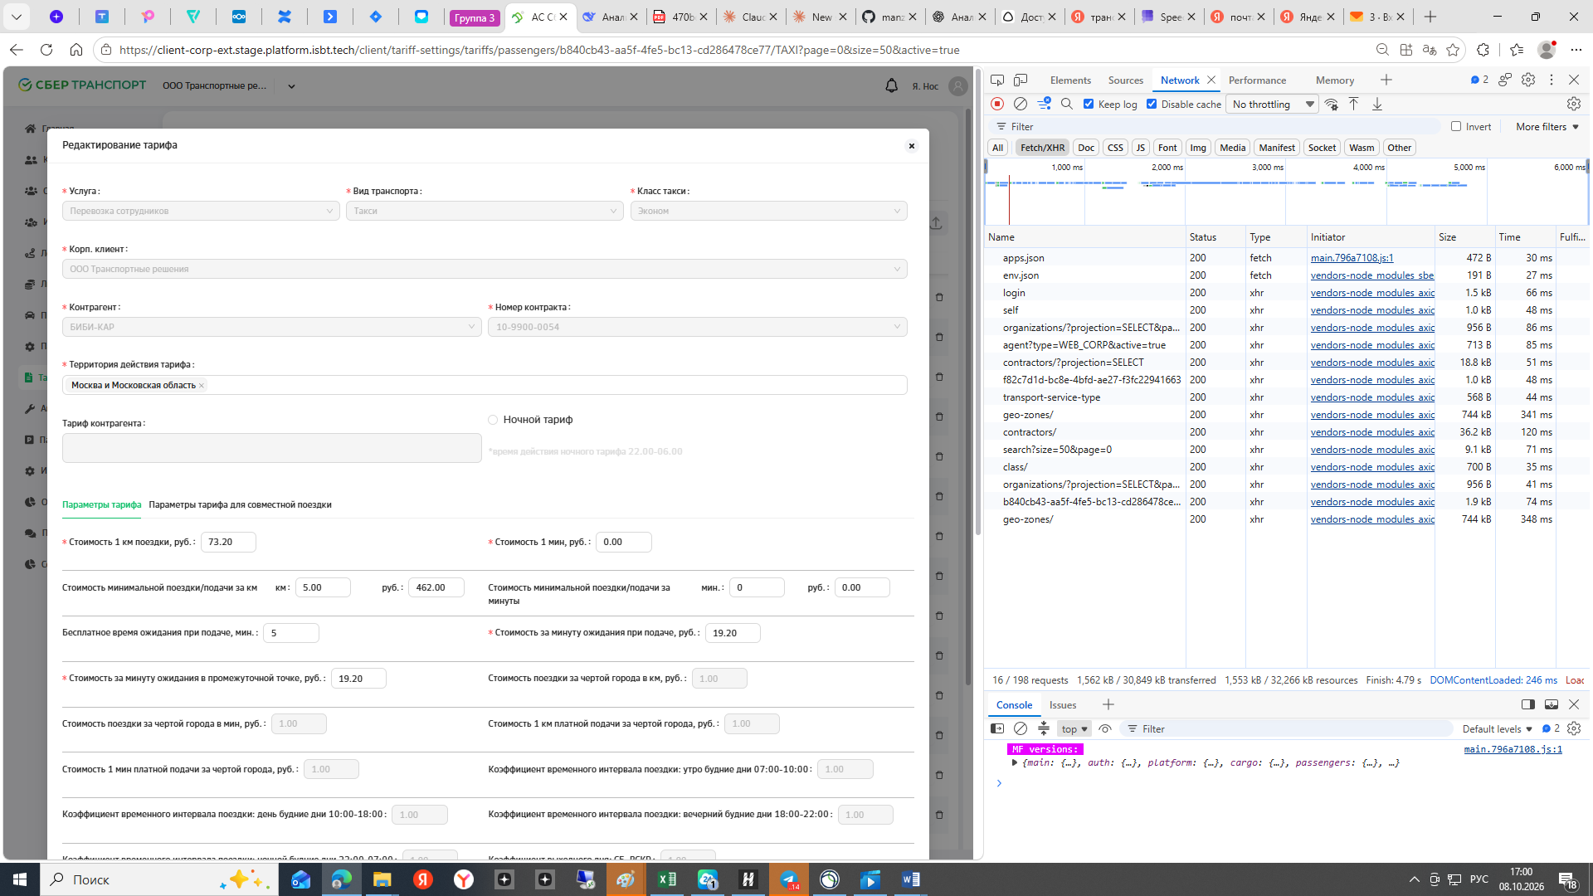

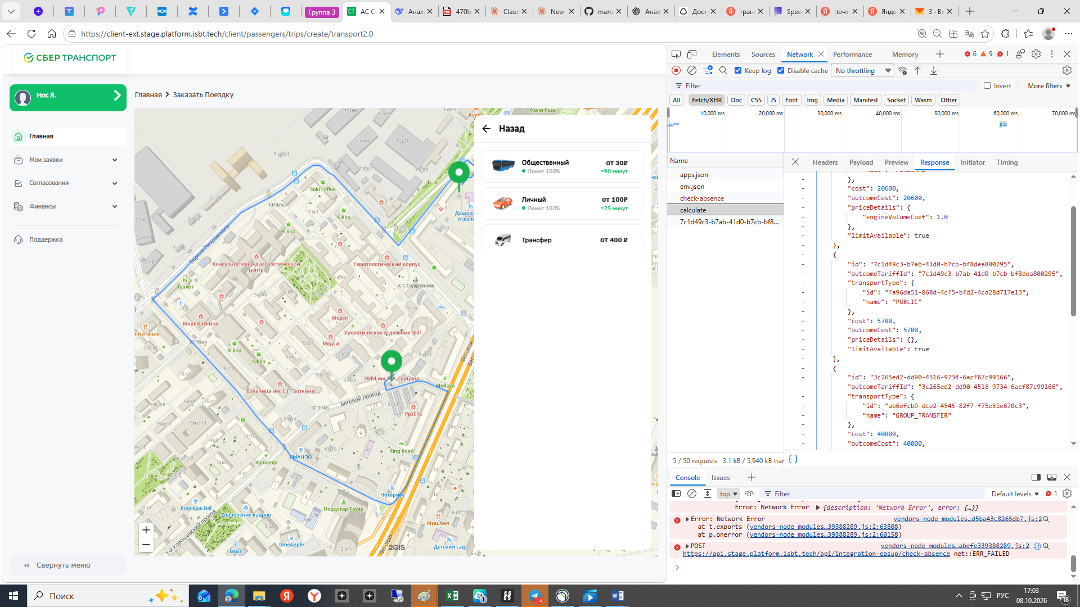

- {distance: 2.343, time: 380000, tripDate: 1791468135000,…}
  - distance: 2.343
  - employeeId: "0b988155-d3ea-4c74-b22e-44ec14ca9bb8"
  - organizationId: "f82c7d1d-bc8e-4bfd-ae27-f3fc22941663"
  - startPoint: {country: "Россия", region: "Москва", city: "Москва", street: "2-й Боткинский проезд", house: "3",…}
    - city: "Москва"
    - country: "Россия"
    - house: "3"
    - latitude: 55.77903438726017
    - longitude: 37.55482773240111
    - region: "Москва"
    - street: "2-й Боткинский проезд"
    - waitTime: 0
    - _addressString: "2-й Боткинский проезд, 3, Москва, Россия"
    - _addressStringWithRegion: "Москва, 2-й Боткинский проезд, 3"
    - _regionData: ""
  - time: 380000
  - timeZone: "GMT+03"
  - tripDate: 1791468135000
  - waitingTime: 0
  - waypoints: [,…]
    - 0: {country: "Россия", region: "Москва", city: "Москва", street: "2-й Боткинский проезд", house: "3",…}
      - city: "Москва"
      - country: "Россия"
      - house: "3"
      - latitude: 55.77903438726017
      - longitude: 37.55482773240111
      - region: "Москва"
      - street: "2-й Боткинский проезд"
      - waitTime: 0
      - _addressString: "2-й Боткинский проезд, 3, Москва, Россия"
      - _addressStringWithRegion: "Москва, 2-й Боткинский проезд, 3"
      - _regionData: ""
    - 1: {country: "Россия", region: "Москва", city: "Москва", street: "1-й Боткинский проезд", house: "4",…}
      - city: "Москва"
      - country: "Россия"
      - house: "4"
      - latitude: 55.78303021275057
      - longitude: 37.55736789853001
      - region: "Москва"
      - street: "1-й Боткинский проезд"
      - waitTime: 0
      - _addressString: "1-й Боткинский проезд, 4, Москва, Россия"
      - _addressStringWithRegion: "Москва, 1-й Боткинский проезд, 4"
      - _regionData: ""
[
{
"id": "c82a5af0-f743-4dbb-b946-eb62ba538311",
"outcomeTariffId": "c82a5af0-f743-4dbb-b946-eb62ba538311",
"transportType": {
"id": "1a33601d-4db4-4720-8d09-95f015770fe0",
"name": "PERSONAL"
},
"cost": 20600,
"outcomeCost": 20600,
"priceDetails": {
"engineVolumeCoef": 1.0
},
"limitAvailable": true
},
{
"id": "7c1d49c3-b7ab-41d0-b7cb-bf8dea800295",
"outcomeTariffId": "7c1d49c3-b7ab-41d0-b7cb-bf8dea800295",
"transportType": {
"id": "fa96da51-068d-4cf5-bfd2-4cd28d717e13",
"name": "PUBLIC"
},
"cost": 5700,
"outcomeCost": 5700,
"priceDetails": {},
"limitAvailable": true
},
{
"id": "3c265ed2-dd90-4516-9734-6acf87c99166",
"outcomeTariffId": "3c265ed2-dd90-4516-9734-6acf87c99166",
"transportType": {
"id": "ab6efcb9-dce2-4545-82f7-f75e51e670c3",
"name": "GROUP_TRANSFER"
},
"cost": 40000,
"outcomeCost": 40000,
"priceDetails": {},
"groupTransferClass": "TRANSFER",
"limitAvailable": true
}
- ] 0: {id: "c82a5af0-f743-4dbb-b946-eb62ba538311", outcomeTariffId: "c82a5af0-f743-4dbb-b946-eb62ba538311",…}
  - cost: 20600
  - id: "c82a5af0-f743-4dbb-b946-eb62ba538311"
  - limitAvailable: true
  - outcomeCost: 20600
  - outcomeTariffId: "c82a5af0-f743-4dbb-b946-eb62ba538311"
  - priceDetails: {engineVolumeCoef: 1}
    - engineVolumeCoef: 1
  - transportType: {id: "1a33601d-4db4-4720-8d09-95f015770fe0", name: "PERSONAL"}
    - id: "1a33601d-4db4-4720-8d09-95f015770fe0"
    - name: "PERSONAL"
- 1: {id: "7c1d49c3-b7ab-41d0-b7cb-bf8dea800295", outcomeTariffId: "7c1d49c3-b7ab-41d0-b7cb-bf8dea800295",…}
  - cost: 5700
  - id: "7c1d49c3-b7ab-41d0-b7cb-bf8dea800295"
  - limitAvailable: true
  - outcomeCost: 5700
  - outcomeTariffId: "7c1d49c3-b7ab-41d0-b7cb-bf8dea800295"
  - priceDetails: {}
  - transportType: {id: "fa96da51-068d-4cf5-bfd2-4cd28d717e13", name: "PUBLIC"}
    - id: "fa96da51-068d-4cf5-bfd2-4cd28d717e13"
    - name: "PUBLIC"
- 2: {id: "3c265ed2-dd90-4516-9734-6acf87c99166", outcomeTariffId: "3c265ed2-dd90-4516-9734-6acf87c99166",…}
  - cost: 40000
  - groupTransferClass: "TRANSFER"
  - id: "3c265ed2-dd90-4516-9734-6acf87c99166"
  - limitAvailable: true
  - outcomeCost: 40000
  - outcomeTariffId: "3c265ed2-dd90-4516-9734-6acf87c99166"
  - priceDetails: {}
  - transportType: {id: "ab6efcb9-dce2-4545-82f7-f75e51e670c3", name: "GROUP_TRANSFER"}
    - id: "ab6efcb9-dce2-4545-82f7-f75e51e670c3"
    - name: "GROUP_TRANSFER"
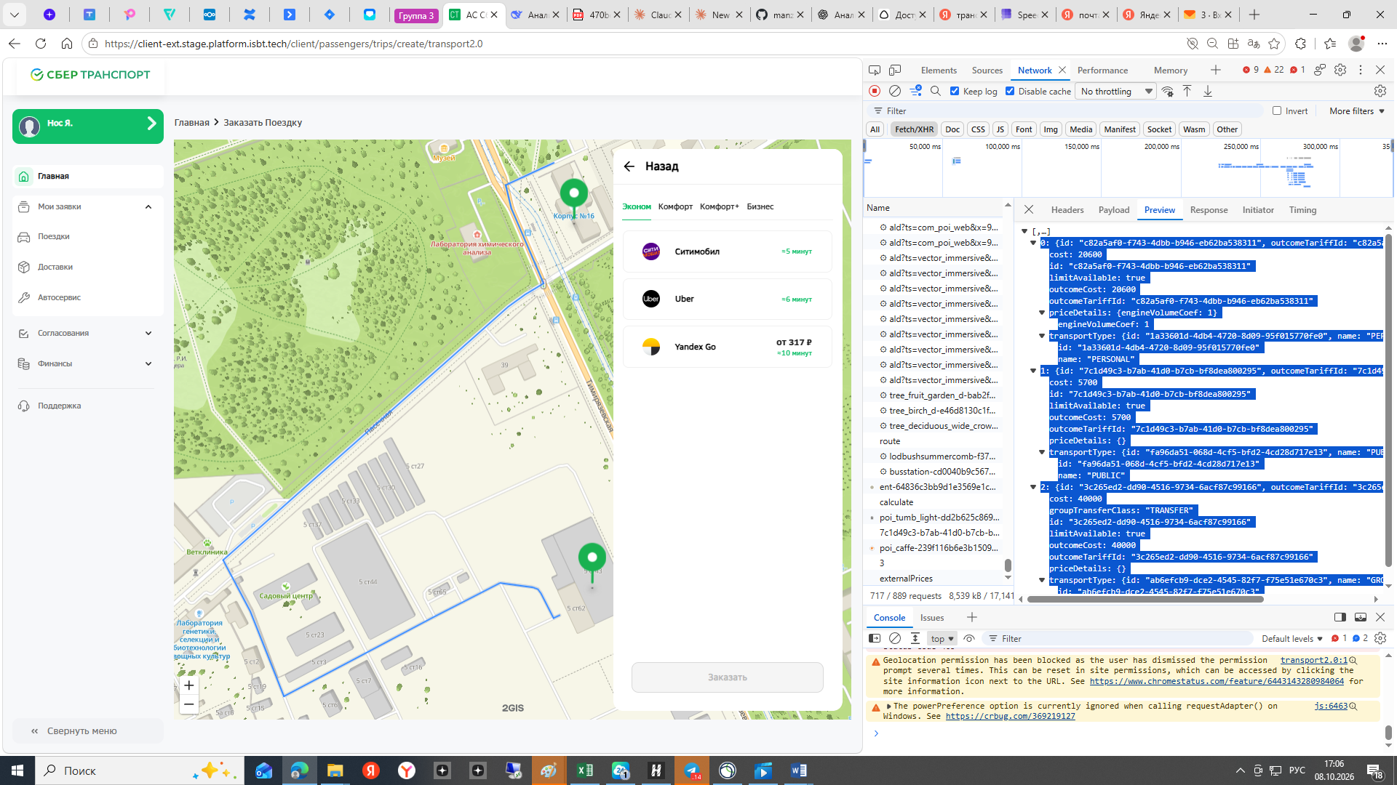

- {distance: 0.589, time: 118000, tripDate: 1791468627000,…}
  - distance: 0.589
  - employeeId: "0b988155-d3ea-4c74-b22e-44ec14ca9bb8"
  - organizationId: "f82c7d1d-bc8e-4bfd-ae27-f3fc22941663"
  - startPoint: {country: "Россия", region: "Москва", city: "Москва", latitude: 55.76241972148833,…}
    - city: "Москва"
    - country: "Россия"
    - latitude: 55.76241972148833
    - longitude: 37.57939099603549
    - region: "Москва"
    - waitTime: 0
    - _addressString: "Москва, Россия"
    - _addressStringWithRegion: "Москва, "
    - _regionData: ""
  - time: 118000
  - timeZone: "GMT+03"
  - tripDate: 1791468627000
  - waitingTime: 0
  - waypoints: [{country: "Россия", region: "Москва", city: "Москва", latitude: 55.76241972148833,…},…]
    - 0: {country: "Россия", region: "Москва", city: "Москва", latitude: 55.76241972148833,…}
      - city: "Москва"
      - country: "Россия"
      - latitude: 55.76241972148833
      - longitude: 37.57939099603549
      - region: "Москва"
      - waitTime: 0
      - _addressString: "Москва, Россия"
      - _addressStringWithRegion: "Москва, "
      - _regionData: ""
    - 1: {country: "Россия", region: "Москва", city: "Москва", street: "Зоологическая улица", house: "12 ст3",…}
      - city: "Москва"
      - country: "Россия"
      - house: "12 ст3"
      - latitude: 55.76489092183026
      - longitude: 37.58219769230919
      - region: "Москва"
      - street: "Зоологическая улица"
      - waitTime: 0
      - _addressString: "Зоологическая улица, 12 ст3, Москва, Россия"
      - _addressStringWithRegion: "Москва, Зоологическая улица, 12 ст3"
      - _regionData: ""
[
{
"id": "c82a5af0-f743-4dbb-b946-eb62ba538311",
"outcomeTariffId": "c82a5af0-f743-4dbb-b946-eb62ba538311",
"transportType": {
"id": "1a33601d-4db4-4720-8d09-95f015770fe0",
"name": "PERSONAL"
},
"cost": 2000,
"outcomeCost": 2000,
"priceDetails": {
"engineVolumeCoef": 1.0
},
"limitAvailable": true
},
{
"id": "7c1d49c3-b7ab-41d0-b7cb-bf8dea800295",
"outcomeTariffId": "7c1d49c3-b7ab-41d0-b7cb-bf8dea800295",
"transportType": {
"id": "fa96da51-068d-4cf5-bfd2-4cd28d717e13",
"name": "PUBLIC"
},
"cost": 5700,
"outcomeCost": 5700,
"priceDetails": {},
"limitAvailable": true
},
{
"id": "3c265ed2-dd90-4516-9734-6acf87c99166",
"outcomeTariffId": "3c265ed2-dd90-4516-9734-6acf87c99166",
"transportType": {
"id": "ab6efcb9-dce2-4545-82f7-f75e51e670c3",
"name": "GROUP_TRANSFER"
},
"cost": 40000,
"outcomeCost": 40000,
"priceDetails": {},
"groupTransferClass": "TRANSFER",
"limitAvailable": true
}
] 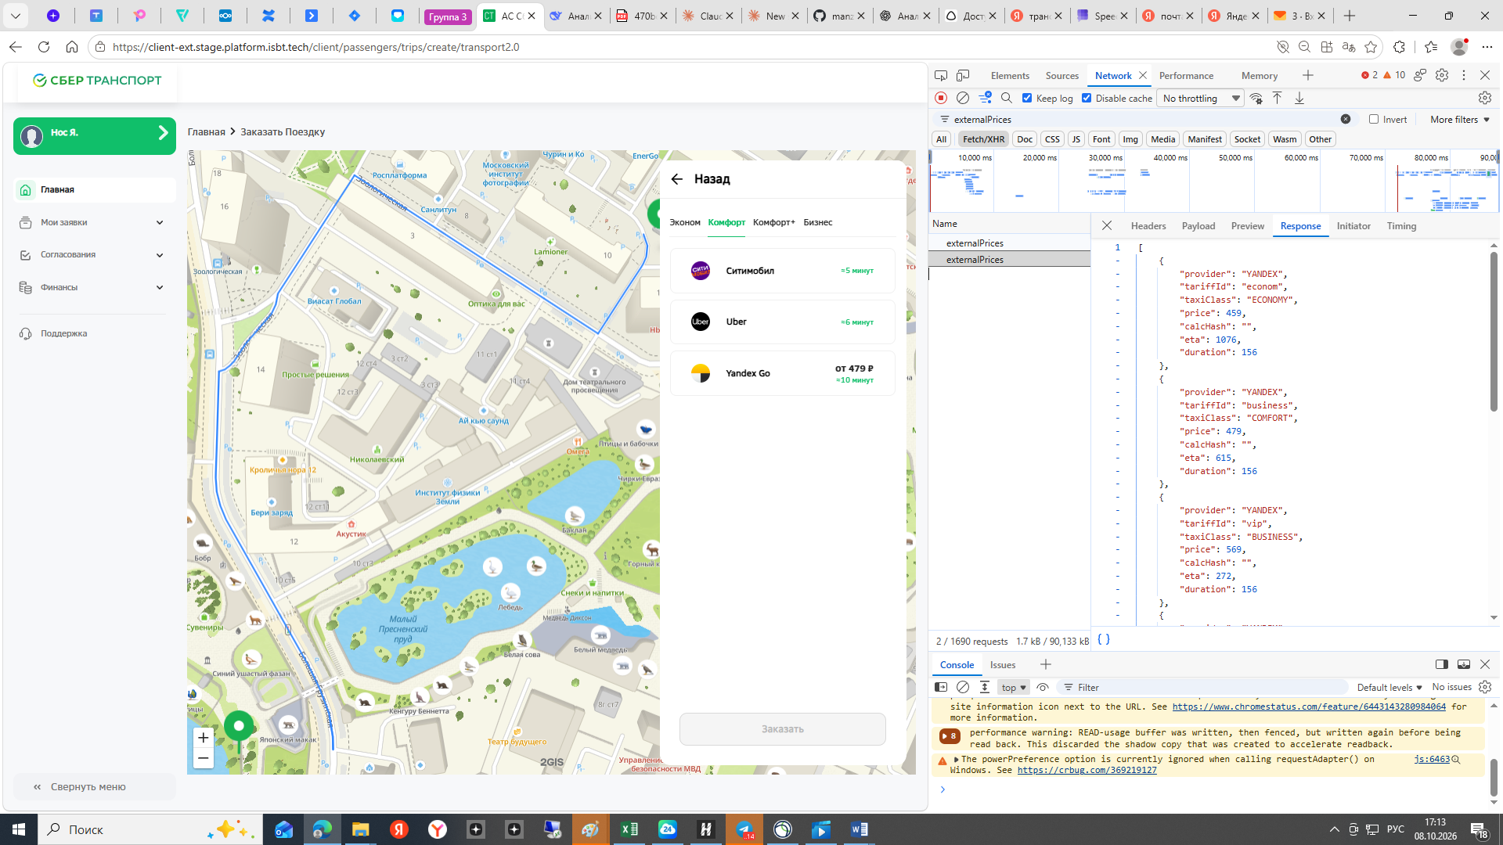

- {,…}
  - author: {userId: "0b988155-d3ea-4c74-b22e-44ec14ca9bb8", firstName: "Яна", lastName: "Нос", patronymic: "",…}
    - approvals: 5
    - availableTransportTypes: []
    - consent: true
    - delegatedById: ""
    - departmentId: "0ba6eb91-f88b-4556-b620-859768e6cc2d"
    - email: "nos_y@garpix.com"
    - firstName: "Яна"
    - humanReadableId: "US-0013-00000314"
    - id: "0b988155-d3ea-4c74-b22e-44ec14ca9bb8"
    - isDepartmentHead: false
    - isPhoneConfirmed: false
    - lastName: "Нос"
    - mobilePhone: "+79047762400"
    - orgStructureType: "EXTERNAL"
    - organizationId: "f82c7d1d-bc8e-4bfd-ae27-f3fc22941663"
    - patronymic: ""
    - personnelNumber: "59317"
    - positionId: "c9ea5e6b-b3e3-43ba-b5a3-cc15d5105358"
    - status: "ACTIVE"
    - supervisorId: ""
    - userId: "0b988155-d3ea-4c74-b22e-44ec14ca9bb8"
  - desiredDate: 1791468629980
  - expected: {distance: 0.589, time: 118000,…}
    - distance: 0.589
    - segments: [{distance: 0.014, time: 2000,…}, {distance: 0.225, time: 27000,…}, {distance: 0.13, time: 25000,…},…]
      - 0: {distance: 0.014, time: 2000,…}
        - coordinates: [{latitude: 55.762419, longitude: 37.57939}, {latitude: 55.762357, longitude: 37.579409},…]
          - 0: {latitude: 55.762419, longitude: 37.57939}
            - latitude: 55.762419
            - longitude: 37.57939
          - 1: {latitude: 55.762357, longitude: 37.579409}
            - latitude: 55.762357
            - longitude: 37.579409
          - 2: {latitude: 55.76229, longitude: 37.579412}
        - distance: 0.014
        - time: 2000
      - 1: {distance: 0.225, time: 27000,…}
      - 2: {distance: 0.13, time: 25000,…}
      - 3: {distance: 0.158, time: 38000,…}
      - 4: {distance: 0.062, time: 25000,…}
      - 5: {distance: 0, time: 0, coordinates: []}
    - time: 118000
    - waypoints: [{country: "Россия", region: "Москва", city: "Москва", latitude: 55.76241972148833,…},…]
      - 0: {country: "Россия", region: "Москва", city: "Москва", latitude: 55.76241972148833,…}
        - city: "Москва"
        - country: "Россия"
        - latitude: 55.76241972148833
        - longitude: 37.57939099603549
        - region: "Москва"
        - waitTime: 0
        - _addressString: "Москва, Россия"
        - _addressStringWithRegion: "Москва, "
        - _regionData: ""
      - 1: {country: "Россия", region: "Москва", city: "Москва", street: "Зоологическая улица", house: "12 ст3",…}
        - city: "Москва"
        - country: "Россия"
        - house: "12 ст3"
        - latitude: 55.76489092183026
        - longitude: 37.58219769230919
        - region: "Москва"
        - street: "Зоологическая улица"
        - waitTime: 0
        - _addressString: "Зоологическая улица, 12 ст3, Москва, Россия"
        - _addressStringWithRegion: "Москва, Зоологическая улица, 12 ст3"
        - _regionData: ""
  - passenger: {userId: "0b988155-d3ea-4c74-b22e-44ec14ca9bb8", firstName: "Яна", lastName: "Нос", patronymic: "",…}
    - approvals: 5
    - availableTransportTypes: []
    - consent: true
    - delegatedById: ""
    - departmentId: "0ba6eb91-f88b-4556-b620-859768e6cc2d"
    - email: "nos_y@garpix.com"
    - firstName: "Яна"
    - humanReadableId: "US-0013-00000314"
    - id: "0b988155-d3ea-4c74-b22e-44ec14ca9bb8"
    - isDepartmentHead: false
    - isPhoneConfirmed: false
    - lastName: "Нос"
    - mobilePhone: "+79047762400"
    - orgStructureType: "EXTERNAL"
    - organizationId: "f82c7d1d-bc8e-4bfd-ae27-f3fc22941663"
    - patronymic: ""
    - personnelNumber: "59317"
    - positionId: "c9ea5e6b-b3e3-43ba-b5a3-cc15d5105358"
    - status: "ACTIVE"
    - supervisorId: ""
    - userId: "0b988155-d3ea-4c74-b22e-44ec14ca9bb8"
  - passengerCount: 1
  - purpose: {label: "Гемба", id: "4a94d459-5362-41d6-b34b-b79401c4282f"}
    - id: "4a94d459-5362-41d6-b34b-b79401c4282f"
    - label: "Гемба"
  - requestOptions: []
  - source: "WEB"
  - taxiClass: "ECONOMY"
  - timeZone: "GMT+03"
  - transportType: "TAXI"
[
{
"provider": "YANDEX",
"tariffId": "econom",
"taxiClass": "ECONOMY",
"price": 1429,
"calcHash": "",
"eta": 794,
"duration": 3002
},
{
"provider": "YANDEX",
"tariffId": "business",
"taxiClass": "COMFORT",
"price": 1613,
"calcHash": "",
"eta": 281,
"duration": 3002
},
{
"provider": "YANDEX",
"tariffId": "vip",
"taxiClass": "BUSINESS",
"price": 2092,
"calcHash": "",
"eta": 696,
"duration": 3002
},
{
"provider": "YANDEX",
"tariffId": "comfortplus",
"taxiClass": "COMFORT_PLUS",
"price": 1694,
"calcHash": "",
"eta": 518,
"duration": 3002
}
]

Итог исследования стенда по вопросу 1 (тарифы для справочника избранных маршрутов)

1. Стенд и организация
- Стенд: client-corp-ext.stage.platform.isbt.tech (корп. кабинет), client-ext.stage.platform.isbt.tech (клиентский интерфейс).
- Организация: ООО Транспортные решения, organizationId: f82c7d1d-bc8e-4bfd-ae27-f3fc22941663.
- Манжерока на стенде нет — появится после разработки сервиса избранных маршрутов.
- Тестовый стенд — данные условные, картину нужно перепроверить после появления Манжерока.

2. Тарифы организации — 17 активных
Из POST /api/tariffs/search (size=50):
Вид транспорта | Количество | Тарифы
TAXI | 10 | 37, 38, 40, 42, 44, 45, 51, 52, 53, 55
GROUP_TRANSFER | 3 | 48, 49, 50
PERSONAL | 2 | 2, 46
PUBLIC | 2 | 3, 24
Ни одного ночного тарифа (isNightTariff: false у всех).

По регионам для TAXI
Регион | Тариф | Контрагент | Договор | Класс
Москва | 37 | БИБИ-КАР | 10-9900-0054 | Эконом
Москва | 40 | БИБИ-КАР | 10-9900-0054 | Комфорт
Москва | 42 | БИБИ-КАР | 10-9900-0054 | Бизнес
Москва | 51 | Автопарк | 101 | Служебный
Москва | 52 | Автопарк | 101 | Комфорт+
Москва | 55 | Автопарк | 101 | Эконом
Приморский край | 38 | ИП Широков | 112 | —
Ростовская область | 44 | Служебный Ростов | — | —
Оренбургская область | 45 | ООО Бен-Газ-Сакмара | — | —
Республика Алтай | 53 | Автопарк | 101 | Служебный

GROUP_TRANSFER
Регион | Тариф | Контрагент | Договор
Москва | 48 | Автопарк | 301
Алтайский край | 49 | Автопарк | 301
Республика Алтай | 50 | Автопарк | 301
Ключевой факт: в Москве по классу Эконом — два тарифа от разных контрагентов (БИБИ-КАР и Автопарк). Сценарий «несколько договоров на один класс» на стенде существует.

3. POST /api/tariffs/search — что возвращает
Payload:
text
{
"page": {"pageNumber": 1, "pageSize": 10},
"active": true,
"serviceType": "EMPLOYEE_TRANSPORTATION"
}
Response — элемент:
text
{
"id": "uuid",
"humanReadableId": "TF-0013-00000048",
"region": "Москва и Московская область",
"regionId": "uuid",
"transportType": "GROUP_TRANSFER",
"serviceType": "EMPLOYEE_TRANSPORTATION",
"active": true,
"organizationId": "uuid",
"contractId": "uuid",
"contractNumber": "301",
"contractorId": "uuid",
"contractorName": "Автопарк Транспортные решения АПИ",
"isNightTariff": false
}
Чего нет:
- класса тарифа;
- типа договора (contractType);
- признаков трансфера (VIP, животное, негабарит, кресло);
- цены;
- периода действия.
Вывод: search не подходит для выбора тарифа в справочнике по классу и цене.

4. POST /api/tariffs/calculate — что возвращает
Payload:
text
{
"distance": 0.589,
"time": 118000,
"tripDate": 1791468627000,
"employeeId": "uuid",
"organizationId": "uuid",
"startPoint": {...},
"waypoints": [...]
}
Response — три тарифа, по одному на вид транспорта:
transportType | id тарифа | cost | Класс
PERSONAL | c82a5af0… | 2000 | —
PUBLIC | 7c1d49c3… | 5700 | —
GROUP_TRANSFER | 3c265ed2… | 40000 | groupTransferClass: "TRANSFER"
Чего нет:
- TAXI вообще отсутствует в ответе;
- класса для PERSONAL и PUBLIC;
- списка классов.
Вывод: calculate не даёт список классов такси. Для справочника избранных маршрутов не подходит.

5. POST /api/tariffs/externalPrices — что возвращает
Payload (после выбора класса):
text
{
"author": {userId, firstName, lastName, organizationId, departmentId, positionId, ...},
"passenger": {...},
"desiredDate": 1791468629980,
"expected": {
"distance": 18.3,
"time": 2037000,
"segments": [...],
"waypoints": [...]
},
"transportType": "TAXI",
"taxiClass": "ECONOMY",
"source": "WEB",
"passengerCount": 1,
"purpose": {id, label},
"requestOptions": []
}
Response (для класса Комфорт+):
text
[
{"provider": "YANDEX", "tariffId": "econom", "taxiClass": "ECONOMY", "price": 1429, "eta": 794, "duration": 3002},
{"provider": "YANDEX", "tariffId": "business", "taxiClass": "COMFORT", "price": 1613, "eta": 281, "duration": 3002},
{"provider": "YANDEX", "tariffId": "vip", "taxiClass": "BUSINESS", "price": 2092, "eta": 696, "duration": 3002},
{"provider": "YANDEX", "tariffId": "comfortplus", "taxiClass": "COMFORT_PLUS", "price": 1694, "eta": 518, "duration": 3002}
]
Особенности:
- tariffId — строковый код (econom, business, vip, comfortplus), не UUID;
- класс приходит в ответе (taxiClass);
- цена — целое число (рубли);
- eta, duration — секунды;
- только provider: "YANDEX" в проверенном ответе;
- корпоративных перевозчиков нет.

6. Классы такси — статический список
Отдельного запроса на список классов нет. При переключении таба «Комфорт+» уходит только новый externalPrices с taxiClass: "COMFORT_PLUS".
Список классов (Эконом, Комфорт, Комфорт+, Бизнес) — статический в интерфейсе.
Вывод: для справочника избранных маршрутов сервис должен сам знать список классов такси, не получая его запросом.

7. Развилка: два мира тарифов
Мир 1 — корпоративные тарифы (БИБИ-КАР, Автопарк):
- видны только в корп. кабинете через search;
- класса и цены search не даёт;
- calculate для такси не работает;
- механизма для выбора в справочнике нет.
Мир 2 — внешние агрегаторы (YANDEX):
- видны в клиентском интерфейсе через externalPrices;
- дают класс, провайдера, цену, tariffId (строковый);
- механизм для выбора в справочнике есть.
Ситимобил и Uber отображаются в UI без цены — возможно, они не ответили, или для них нет интеграции.

8. Что это значит для T01.1 / T01.2

Для T01.1 (модель данных)
- Поле tariff_id в favorite_route должно принимать два разных типа идентификатора:
  - UUID — для корпоративных тарифов;
  - строку — для внешних (econom, business).
- Либо надо унифицировать: хранить provider + tariffId как строку.
- Поле recommended_cost:
  - для внешних тарифов — берётся из externalPrices;
  - для корпоративных — механизм не определён.

Для T01.2 (API)
- Метод POST /api/favorite-routes/calculate (предварительный расчёт) должен работать через externalPrices, если выбраны внешние тарифы.
- Если заказчик потребует корпоративные — нужен A-полный или новый метод в сервисе тарифов.

9. Что задать заказчику
Главный вопрос:
«В справочнике избранных маршрутов управляющий выбирает тариф для расчёта рекомендуемой цены. Какие тарифы должны быть в списке:
- Внешние агрегаторы (Yandex Go) — механизм externalPrices уже есть.
- Корпоративные (БИБИ-КАР, Автопарк) — механизма нет, потребуется разработка.
- Оба — два источника, склейка на стороне сервиса маршрутов.»
Дополнительный вопрос:
«Бывает ли по одному классу несколько действующих договоров с клиентом в одном регионе? Если да — управляющий должен выбирать договор вручную, или система может выбирать его сама?»

10. Что задать архитектору
- Тип tariffId в модели: UUID или строка? Два поля (tariffId + provider) или одно?
- Механизм расчёта recommended_cost для внешних тарифов: переиспользовать externalPrices или новый метод?
- Доступ к externalPrices из сервиса маршрутов: под каким пользователем вызывать?
- Доступ к search и calculate — нужен ли он вообще, если идём по внешним тарифам?

11. Обновлённая формулировка вопроса 1

Вопрос 1. Как сервису маршрутов получить тариф для расчёта рекомендуемой цены
Откуда.
Заказчик (08.10, 16:59–20:37) решил: при создании маршрута управляющий выбирает один тариф из списка действующих тарифов с ценами. Ранее (T01.1, D07, D12; граница 08.10): сервис тарифов не меняется.
Что проверено на стенде.
- POST /api/tariffs/search возвращает только id, номер, регион, transportType, serviceType, active, организацию, договор и контрагента. Класса, типа договора и цены в ответе нет.
- POST /api/tariffs/calculate возвращает по одному тарифу на вид транспорта; TAXI в ответе отсутствует, класса нет.
- POST /api/tariffs/externalPrices возвращает провайдера (YANDEX), tariffId (строковый), taxiClass, price, eta, duration. Класс и цена есть.
- Классы такси — статический список в интерфейсе, отдельного запроса нет.
- В Москве по классу Эконом — два тарифа от разных контрагентов (БИБИ-КАР и Автопарк) — сценарий «несколько договоров на один класс» существует.
Суть вопроса.
Какие тарифы должны попадать в справочник избранных маршрутов и через какой механизм их получать: externalPrices (внешние агрегаторы), A-полный (обход search), или новый метод в сервисе тарифов.
Варианты.
- A-lite + externalPrices. Сервис маршрутов вызывает externalPrices по параметрам маршрута и выбранному классу. Получает провайдера, tariffId (строковый), цену. Работает для внешних агрегаторов. recommended_cost берётся из ответа.
- A-полный. Свой обход search + отдельный GET по каждому тарифу + calculate. Работает для корпоративных тарифов. Десятки вызовов, search не даёт класс, calculate не возвращает такси.
- C. Новый метод в сервисе тарифов — выходит за границу T01.1/T01.4.
Рекомендация.
Зависит от ответа заказчика:
- только внешние → A-lite + externalPrices;
- только корпоративные → A-полный или C;
- оба → два источника, склейка.
Что нужно от заказчика.
Ответ на вопрос: «Какие тарифы в справочнике — внешние, корпоративные или оба?»
Что нужно от архитектора.
- Тип tariffId в модели: UUID, строка или два поля.
- Механизм recommended_cost для внешних тарифов.
- Доступ к externalPrices из сервиса маршрутов.

